**M3 – Improving Website Based on Client Feedback**

I showed the website (as seen in P5) to my client and asked for feedback. He said;

I like the colour scheme and ‘programmer’-style titles. They make the site feel more interesting and relevant to the topic. However, on the content pages, the text goes all the way to the edge of the page, making it difficult to read. Also, I noticed several mistakes in the titles – the C# page has the wrong title, and the ‘more information’ heading is not consistent across different pages.

Taking onboard this feedback, I decided to make the following changes;

* Add a margin to the left side of the page
* Fix mistakes in the page titles
* Ensure that the ‘more information’ header has a consistent format and style

Here is the C# page after the changes have been made

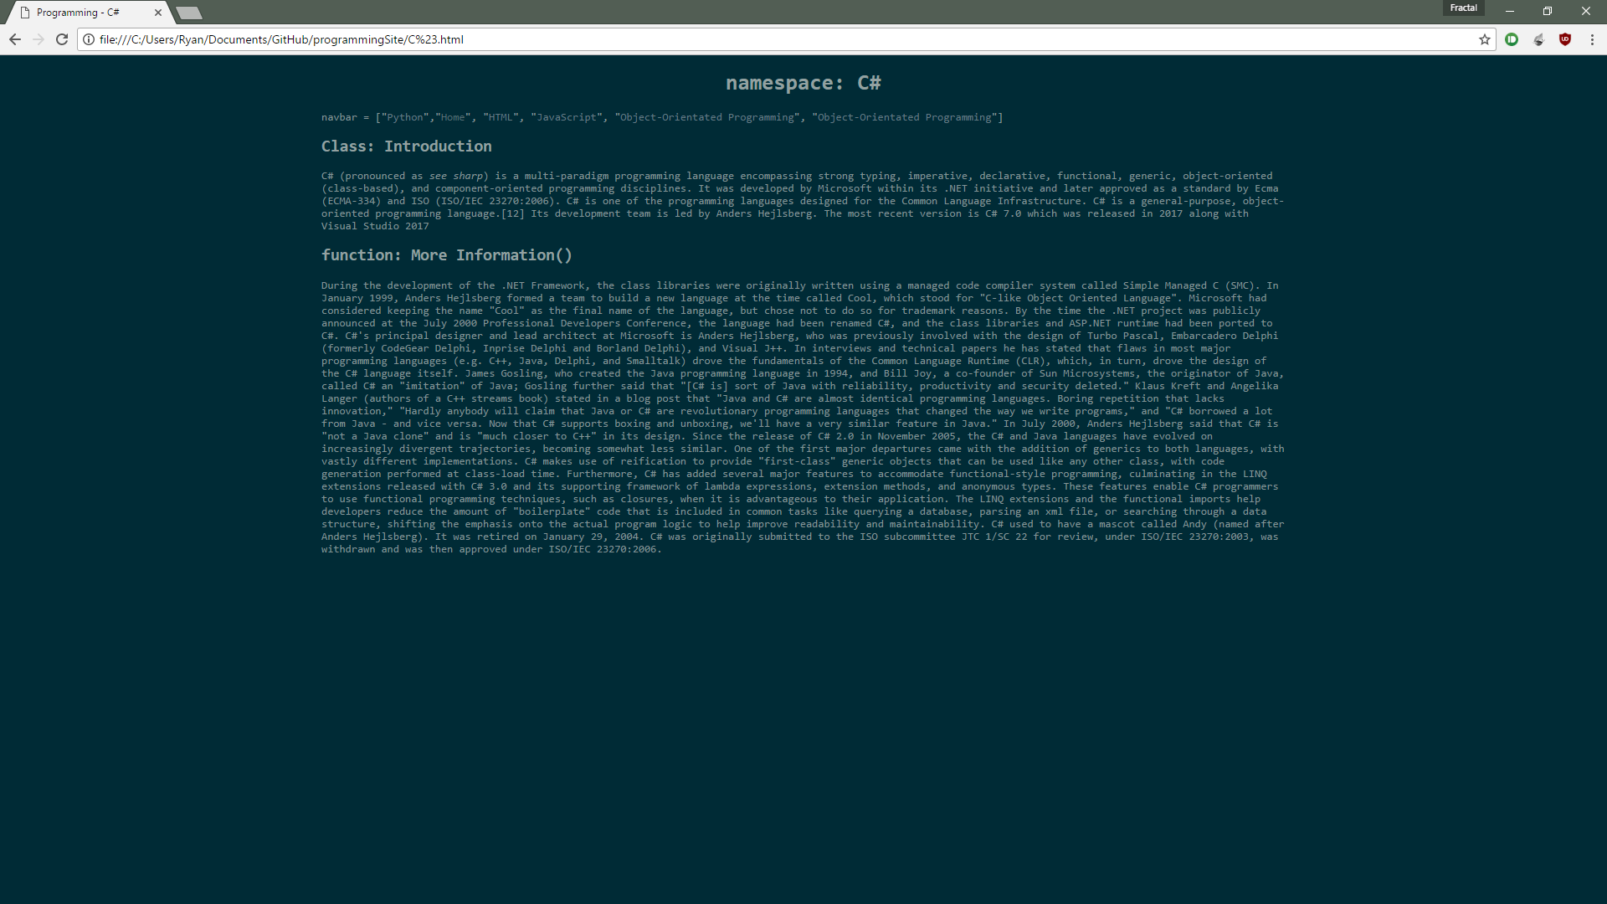

The green shapes show the wider margins and fixed titles.

The client was happy with the content itself.